

SCHOOL OF COMPUTER SCIENCE
AND ARTIFICIAL INTELLIGENCE
DEPARTMENT OF COMPUTER SCIENCE

Assignment Type: Lab
Academic Year:2025-2026
Course Coordinator Name:- Dr Jagjit Singh Dhatterwal
STUDENT NAME:-Pentapuri yeshwanth
ENROLLMENT NUMBER:-2403A51l39
SUBJECT NAME:- Blockchain Engineering
COURSE CODE:-23CS201PE401
YEAR/SEM :- III/II
BATCH:-52

TASK
Assignment submission starts from here

Theory (Brief)
A smart contract is a self-executing program stored on the
blockchain.
The Simple Storage contract is a beginner-level Solidity contract
that allows users to:
• Store a value on the blockchain
• Retrieve the stored value
Remix IDE is a web-based development environment used to
write, compile, deploy, and test Solidity smart contracts.

Code

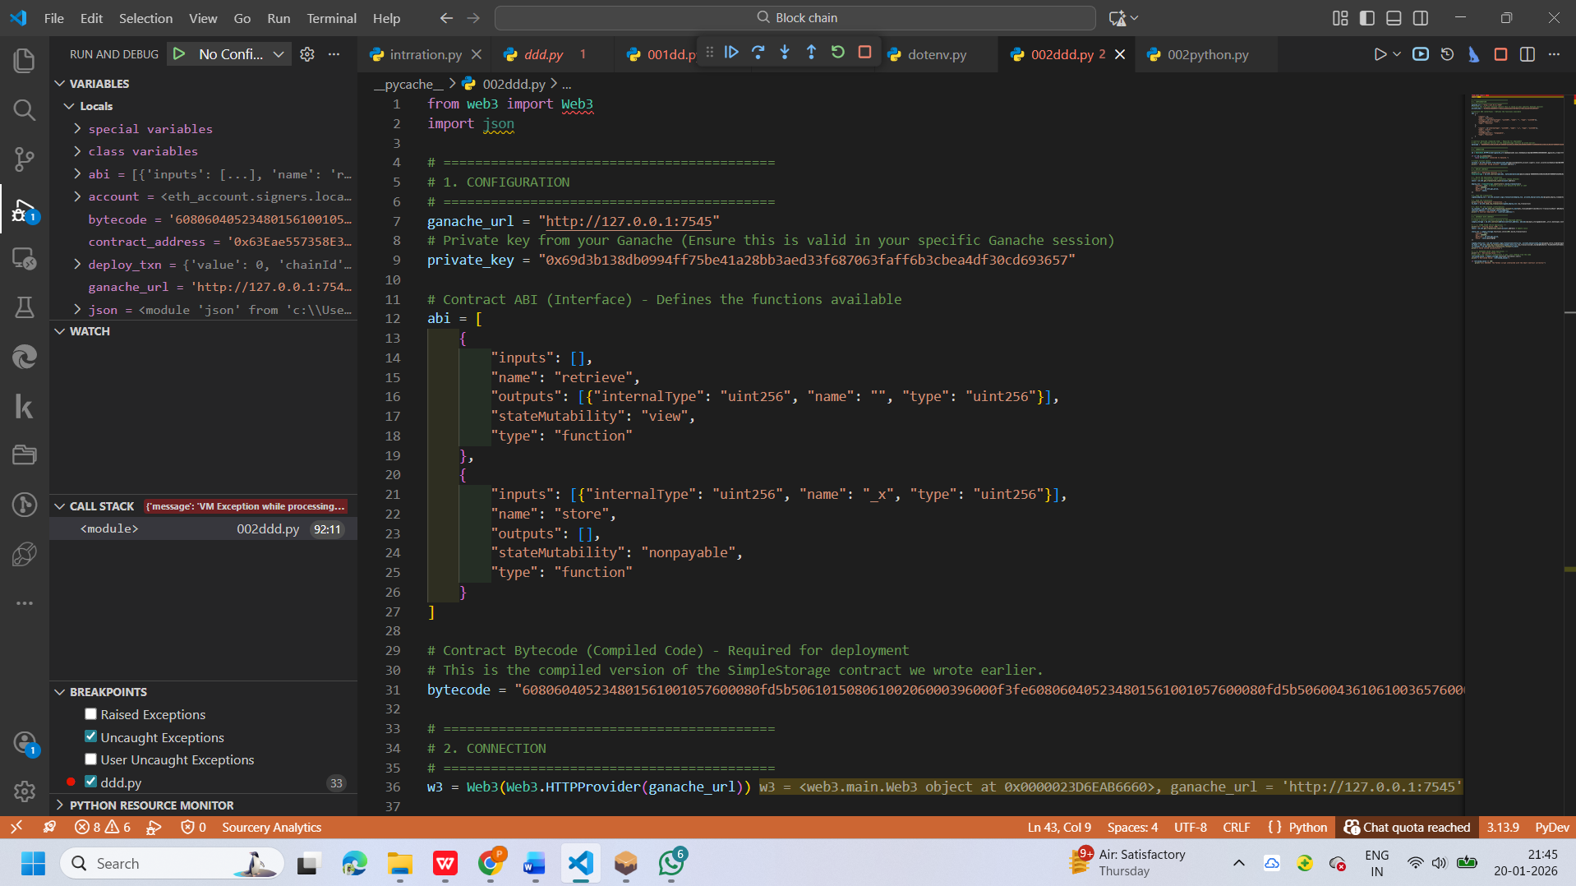

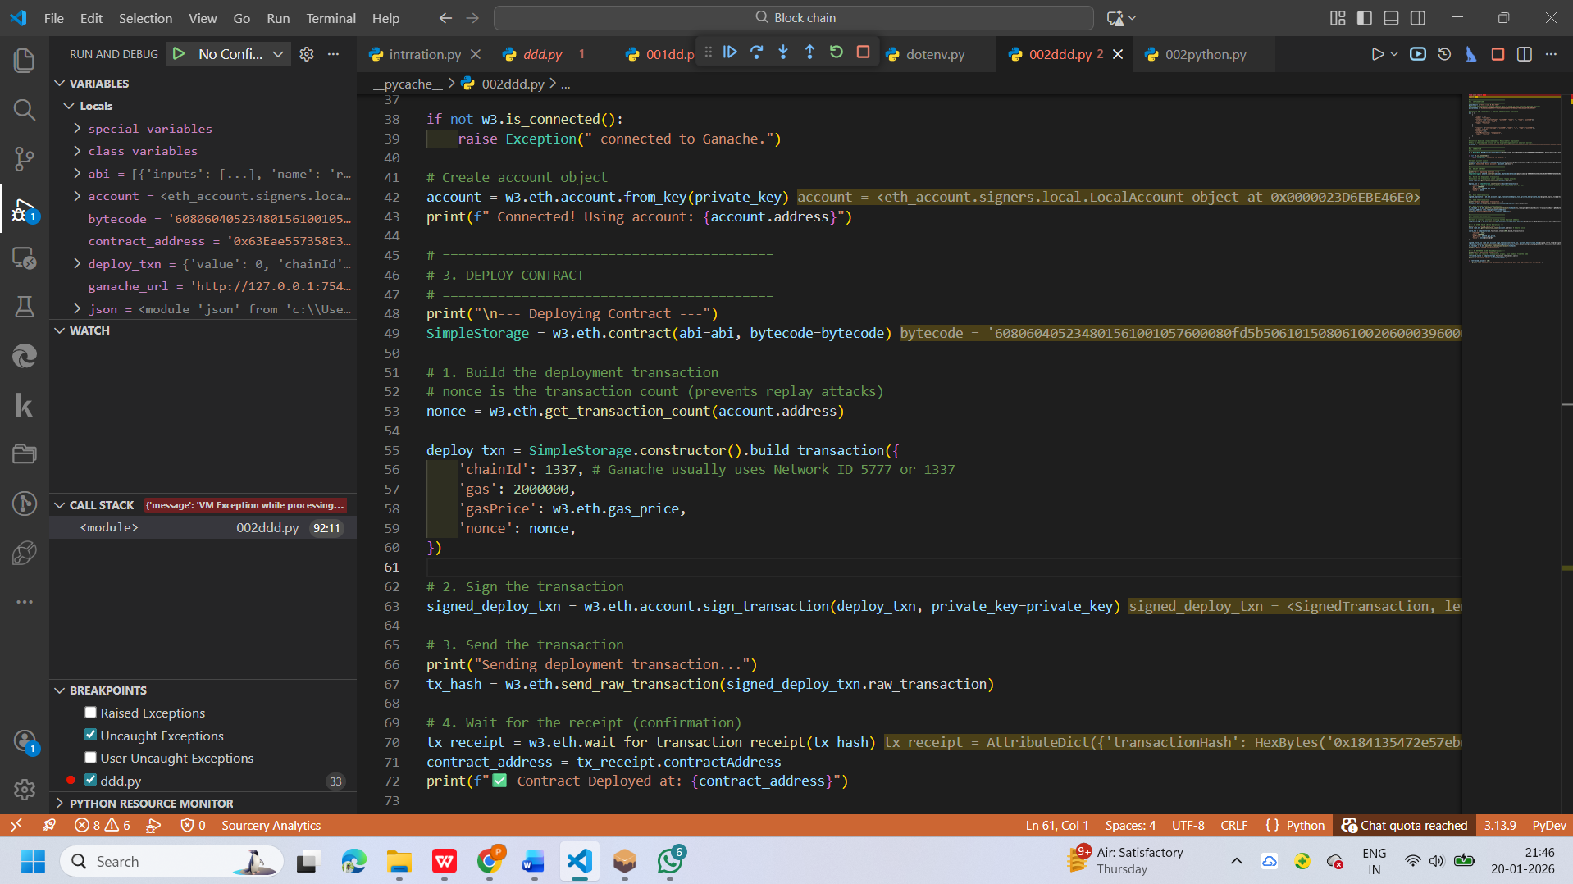

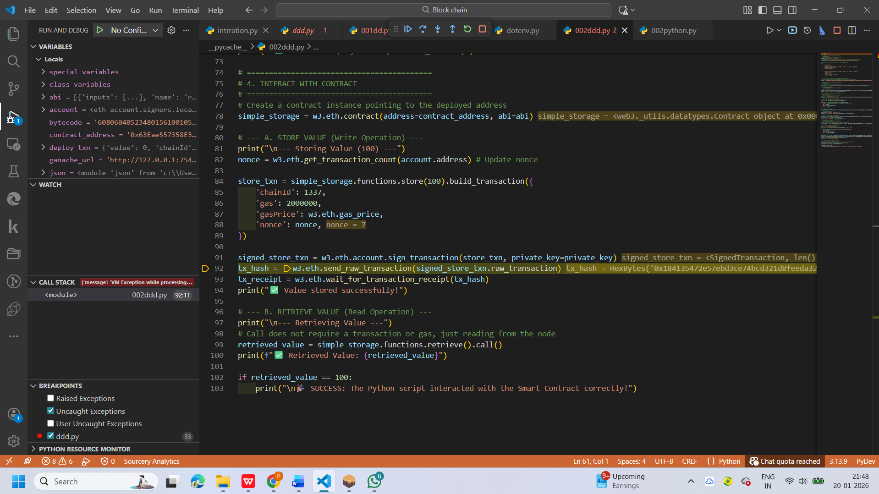

Out put

